SIMATS ENGINEERING (SAVEETHA SCHOOL OF ENGINEERING)
Department of Computer Science and Engineering

ASSESSMENT TOOL 2 – Industry Problem Solving Task

Course Code: | CSA06 | Course Title: | Design and Analysis of Algorithms
CO Assessed: | CO4: Articulation (BL4, BL5) | Assessment: | Assessment Tool 2 – Industry Problem Solving Task
Weightage: | 20% of CIA | Total Marks: | 100
CO4 Statement: | Solve optimization problems using dynamic programming and greedy strategies.
Student Name: | Dinesh Karthick R | Reg. No.: | 192524121
Section / Batch: | 02 | Date: | 21-08-2026
Instructions to Students
- Answer the following question. Total Marks: 100.
- Carefully analyze the given questions.
- Explain in detail with sample code if needed.
- Clearly identify all key issues.
- Provide a thorough analysis with validated results and performance evaluation.

Question Type | Focus Area | Questions
Industry Problem Solving Task | Focus on Solving optimization problems using dynamic programming and greedy strategies | Q1

SECTION A – Industry Problem Solving Task

Q1. Banking Loan Approval Risk Optimization (Decision Algorithms)

A bank must evaluate loan applications to minimize default risk while maximizing profit. Analyze how algorithmic decision-making can be applied. Identify constraints such as credit score, income, and risk factors. Design a solution using optimized decision algorithms. Discuss scalability for large datasets. Evaluate computational complexity. Interpret results in financial risk management.

(Solution implemented and executed in the SIMATS Online Programming Lab – DAA Programming module; screenshots of the code and output are attached below.)

Code of Conduct
I Dinesh Karthick R / 192524121 (Name / Reg No) certify that this submission is my original work and that I have adhered to the guidelines specified for this assessment. I understand that any violation of academic integrity rules will result in disciplinary action.
Signature of the Student:

RUBRICS FOR CALCULATION

Industry Problem Solving Task

Criteria | Weightage | Level 4 – Exemplary | Level 3 – Proficient | Level 2 – Developing | Level 1 – Beginning
Understanding of Industry Problem | 20% | Comprehensive understanding of real-world problem and constraints | Good understanding with minor gaps in requirements | Basic understanding; some  requirements unclear | Poor understanding; misinterprets problem context
Application of Engineering Concepts | 25% | Applies advanced and relevant concepts effectively to solve the problem | Applies appropriate concepts with minor errors | Limited application of concepts | Incorrect or no application of concepts
Solution Design | 25% | Innovative, practical, and feasible solution  aligned with industry standards | Logical and feasible solution with minor gaps | Basic solution with limited feasibility | Unclear or impractical solution
Use of Tools | 15% | Effective use of modern tools, technologies, and real data | Appropriate use of tools with correct implementation | Limited or inconsistent use of tools | Minimal or incorrect use of tools
Analysis | 10% | Thorough analysis with validated results and performance  evaluation | Good analysis with reasonable validation | Basic analysis with limited validation | Poor or no analysis
Professionalism | 5% | Highly professional, well-documented, and clearly presented work | Good documentation and presentation | Basic documentation with somegaps | Poor documentation and presentation

Marks Evaluation:
Criteria | Wt. | Level 4 – Exemplary | Level 3 – Proficient | Level 2 – Developing | Level 1 – Beginning
Understanding of Industry Problem | 20%
Application of Engineering Concepts | 25%
Solution Design | 25%
Use of Tools | 15%
Analysis | 10%
Professionalism | 5%
Total Marks (100):

Faculty In-charge | Course Coordinator | Head of Department
Name: | Name: | Name:
Signature: | Signature: | Signature:
Date: | Date: | Date:
Screenshots – Code Execution Proof (SIMATS Online Programming Lab)
Screenshot 1: Problem statement and C code for the loan approval risk optimization solution
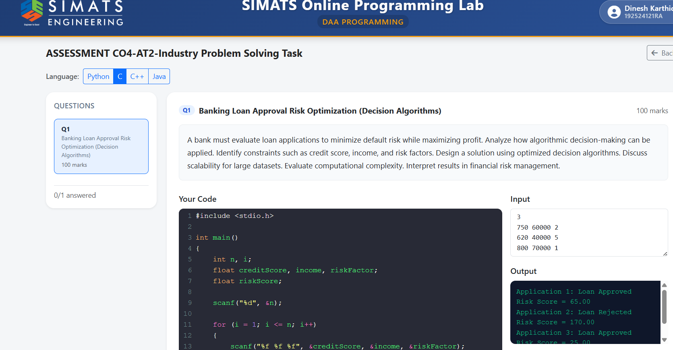
Screenshot 2: Risk score calculation logic and program output
